

Rafik Hariri University

Final Year Project Report

Football Prediction Website

Done by

Farah Flity

Ahmad Maarouf

Mohammad Miri

Sami Shehade

Submitted To

Dr. Mohammad El Abed

This senior project submitted in partial fulfillment of the requirements of the Bachelor of Science degree of Computer Science Major of the College of Arts and Sciences at Rafik Hariri University.

MECHREF, LEBANON

December 2024

Copyright © 2024, all rights reserved

Farah Flity (2021- 0574)

Ahmad Maarouf (2021-)

Mohammad Miri (2020-)

Sami Shehade (2021-)

**Acknowledgements**

We extend our heartfelt appreciation to our research supervisor, Dr. Ghalia Nasereddine, Ph.D. in Computer Science, for her invaluable guidance and continuous support throughout the development of this project. We are also extremely grateful to Dr. Mohammad El Abed, Associate Professor and Chairman of the Computer and Information Systems Department, for his assistance and continuous support. Additionally, we would like to express our sincere thanks to the esteemed faculty members of the Computer Science major, including Dr. Roaa Al-Soloh and Dr. Ali Rammal, for their contributions and guidance throughout our academic journey.

**Abstract**

In today’s fast-paced world of football, providing fans with accurate match predictions and detailed insights into teams and players is essential to keeping them engaged. However, traditional football websites face challenges in offering predictive accuracy, scalability, and ease of use. It is vital that football enthusiasts can easily navigate these platforms and access reliable predictions in real-time. Ensuring the security of user data is a top priority, as is maintaining the website’s performance under high traffic loads. Additionally, the platform must be accessible to all users to promote inclusivity in the sports community. To address these challenges, we developed a Full-Stack Football Prediction website using ReactJs for the frontend and Firebase for the backend. The website integrates machine learning models for match predictions, providing accurate forecasts for upcoming football matches. Our primary goal is to deliver a user-friendly, secure, and visually appealing platform that meets the needs of football fans worldwide.

Keywords: Football predictions, La Liga, ReactJs, Firebase, machine learning, accessibility, user-friendliness, frontend development, scalability, sports analytics.

**Table of Contents**

Acknowledment………………………………………………………………………………...3

Abstract…………………………………………………………………………………………4

Table of Contents……………………………………………………………………………….5

List of Figures…………………………………………………………………………………..8

List of Tables……………………………………………………………………………………9

Introduction and Motivation……………………………………………………...…….….…..12

1. Literature Review……………………………………………………………………….…..14

I- Introduction…………………………………………………………………….……14

II- Competitors Key Features……………………………………………….…….……15

a- Tips 180 Website ……………………………………………..….…..…15

b- Laliga Website……………………………………………….........……16

c-UEFA Website…………………………………………………………. 17

III- Proposed Library system vs Competitors……………………………..……....…....18

IV- Conclusion…………………………………………………………..………...……19

2. System Requirements Analysis and Design ..………………………………………..……….....…..21

I- Introduction…………………………………………………………..…………....…21

II- Requirments……………………………………………………………………....…21

a- Functional Requirments……………………………………………….…......22

b- Non-Functional Requirements ………………………………….…………...23

III- Use Case Diagram………………………………………….…………………….....26

IV- Sequence Diagrams…………………………………….…………………………...27

V- Architecture of our Web App……………………………….……………………….28

VI- Data Modelling…………………………………….……………………………….30

VII- Technologies Used…………………………………….…………………………..34

VIII- Conclusion………………………………….…………………………………….35

3. Prediction model Analysis ……………………………………………………………………36

I- Introduction…………………………………………………………………….……36

II- Transition from forecasting to prediction…………….……………………….……36

III- Dataset and feature engineering…..………………………….…………………....37

IV- Integration with the website….…………………………………….………………..39

V- Conclusion………………………………………………………………………….40

4. Implementation ……………………………………………………………………………...41

I- Introduction…………………………………………………………………….…….41

II- User Interface Description……….…………………………………………….……42

a- Client's Interface…….……………………………………………….…...….42

b- Admin Dashboard and Interface …………………………………….………54

5. Usability Assessment ………………………………………………………………………..62

I- Introduction…………………………………………………………………….…….62

II- Sample…………………. ……….…………………………………………….……62

III- Results of the Survey………………………… …..………………………….……64

VI- Conclusion and Discussion……..………………….………………………………69

**Conclsion and Perspectives**………………. ……….…………………………………………69

**Appendix A** ………………. ……….…………………………………………….…………....71

**References**………………. ……….…………………………………………….…………...…75

**Appendix**………………. ……….…………………………………………….…………...…..77

**List of Figures**

Figure Page

Figure 1. Tips 180 Website Screenshot 16

Figure 2. Laliga Website Screenshot 17

Figure 3.UEFA Website Screenshot 18

Figure 4. Use Case 26

Figure 5. Sequence diagram 1 27

Figure 6. Architecture of the Website 29

Figure 7. Database collections with their documents 31

Figure 8. Team Collection 32

Figure 9. Player Collection 33

Figure 10. Message 33

Figure 11. User Collection 33

Figure 12. notes Collection 34

Figure 13. Final Dataset 37

Figure 14. Model training and result 38

Figure 15. Home Page 42

Figure 16. Create a New Account 43

Figure 17. Login 44

Figure 18. Forget password 45

Figure 19. Contact page 46

Figure 20. Club Page 47

Figure 21. Club Details 48

Figure 22. Squad Page 49

Figure 23. Player profile 50

Figure 24. Match page 50

Figure 25. statistics Page 51

Figure 26. prediction Page 52

Figure 27. About Us Page 53

Figure 28. Admin dashboard 54

Figure 29. Admin Proile 55

Figure 30.User page 56

Figure 31. Team management page 57

Figure 32. Player management page 58

Figure 33. feedback page 58

Figure 34. Admin Notepad 59

Figure 35. Match Management Page 60

Figure 36. Calendar 50

Figure 37. predictionmanagement page 61

Figure 38. Age 62

Figure 39. gender 63

Figure 40. Profession 64

Figure 41. Navigation within the website 64

Figure 42. Easiness and Quickness 65

Figure 43. SAtisfaction 65

Figure 44. Clear information 65

Figure 45. Suggestion 66

Figure 46. Reccomendation 67

**List of Tables**

Table Page

Table 1. Comparison Between Websites 21

Table 2. Advantages of NoSQL databases 33

Table 3. Results of our Survey 74

**Introduction and Motivation**

The world of sports analytics has seen significant advancements, especially in football, where accurate predictions can transform fans' engagement, team strategy, and betting markets. With the vast amount of data available from past games, player statistics, and team performances, football prediction systems have become valuable tools for fans, analysts, and clubs alike. These systems provide insights into likely match outcomes, player performances, and even highlight game-changing events, all through advanced machine learning and data analytics.

Our project aims to address the key challenges in this domain, such as handling complex, large datasets and maintaining real-time prediction accuracy, by adopting an agile development approach. This allows for continuous refinement and collaboration, making our system adaptable to the dynamic world of football. The technical stack includes React.js for building an intuitive, responsive interface, Firebase for scalable backend management, and a machine learning model to generate precise match predictions. By bringing together performance, usability, and real-time data processing, this project aims to:

* Develop a reliable football prediction website with real-time updates.
* Provide users with insightful AI-driven match predictions and analytics.
* Design a seamless, user-friendly experience across all devices.
* Enable registered users to interact, comment on predictions.
* Ensure secure data handling and user authentication to protect sensitive information.

This report is composed of five main chapters:

* Chapter 1: In this chapter, a literature review will be performed to over a previously developed web system to see how they compare to our application.
* Chapter 2: In this chapter, the system requirements will be explored. In addition, the use case and ERD diagram of the project will be illustrated.
* Chapter 3 will analyze the prediction model by detailing the machine learning techniques used, data preprocessing steps, feature engineering, and model evaluation to forecast football match outcomes accurately.
* Chapter 4 that illustrated the main functionality of the designed system.
* Chapter 5 that show the testing and evaluation step of our system.

This report will end by a general conclusion that summarize the project.

**Chapter 1**

**Literature Review**

1. **Introduction**

The football prediction website is a specialized platform designed to provide in-depth information on La Liga clubs, players, and matches while leveraging machine learning for accurate match predictions. The objective of this project is to develop an interactive and user-friendly platform that addresses the limitations found in existing football prediction and analysis websites, focusing specifically on La Liga. This chapter includes a literature review of existing platforms for comparison, such as Tips180, LaLiga.com, and UEFA.com, to highlight where the proposed website improves on user engagement and predictive analytics.

This chapter is structured as follows:

* Section II: A literature review covering the current platforms (Tips180, LaLiga.com, and UEFA.com) and examining their capabilities, strengths, and weaknesses.
* Section III: A comparative analysis between the proposed football prediction system and these existing platforms, emphasizing unique features such as user interactivity, La Liga focus, and AI-driven transparency in predictions.
* Section IV: A concluding summary of insights gained from this review, detailing the anticipated impact of the proposed system.

1. **Competitors Key Features**

In our comparative analysis of the football prediction website with established platforms, the primary focus is on user engagement, AI-driven predictions, and ease of access to detailed La Liga content. Our platform emphasizes an interactive user experience, allowing users to explore comprehensive club, player, and match details without requiring registration, fostering an inclusive and open environment. Key features include personalized user roles and the ability to comment on predictions and team and players information, creating a highly engaging community platform. Unlike traditional sites, we integrate machine learning for match outcome predictions, ensuring high accuracy and transparency Additionally, our website introduces dynamic features like prediction speed enhancements. These advancements aim to build a unique user experience that offers value beyond scores and stats, empowering fans to engage more deeply with La Liga’s dynamic landscape. This comparative analysis informs ongoing improvements, ensuring our platform meets modern football fans' expectations.

* 1. **Tips 180 Website**

Tips180 is a widely recognized platform offering football predictions and betting tips, covering numerous leagues and competitions. The site excels in providing data-driven insights, with a user-friendly interface that makes it easy for fans to access predictions and detailed match analysis. One of its main strengths is the comprehensive use of statistics and head-to-head comparisons, making it a reliable source for bettors seeking informed advice. However, a notable weakness of Tips180 is its limited interactivity—users must subscribe to access full predictions and insights, which can be restrictive for those seeking free information.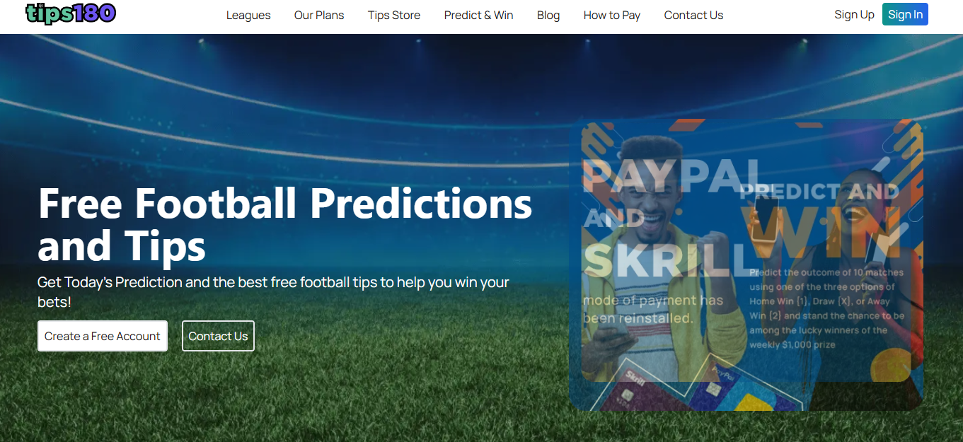

Figure 1. Tips 180 Website Screenshot

* 1. **LA Liga Website**

A LaLiga.com is the official platform for Spain’s La Liga, delivering extensive coverage on all aspects of the league, including news, fixtures, standings, and in-depth statistics for clubs and players. Its primary strength lies in its credibility as an authoritative source for La Liga, providing fans with reliable information and real-time updates on matches and events. The website’s comprehensive data and visually engaging design make it a popular destination for followers of Spanish football. However, it lacks predictive analytics and interactive features that some users may seek, focusing primarily on news and updates rather than user-driven engagement.

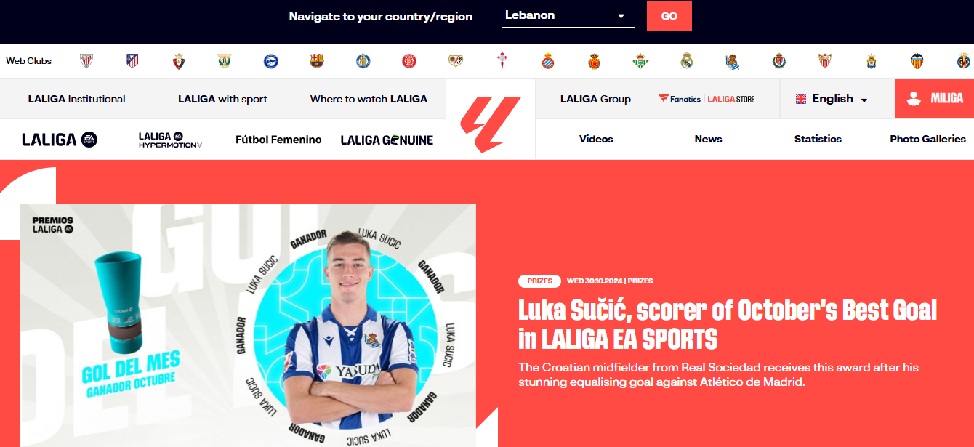

Figure 2. LA Liga Website Screenshot

* 1. **UEFA Website**

UEFA.com is the official site for the Union of European Football Associations, providing extensive coverage of European competitions like the Champions League, Europa League, and others. Known for its wide-reaching content, it includes match schedules, standings, player stats, and news about teams across Europe, making it an essential resource for fans of European football. The site’s strength lies in its depth of coverage, particularly for high-stakes tournaments and European league updates. However, its focus on news and updates means it lacks predictive analytics or league-specific content, like that for La Liga, making it less specialized for fans of individual leagues or those interested in interactive features.



Figure 3. UEFA Website Screenshot

While existing football websites like Tips180, LaLiga.com, and UEFA.com provide robust performance, responsive design, and efficient search and filter functionalities, our football prediction system stands out by offering a focus on La Liga predictions powered by AI. Our system provides in-depth, data-driven forecasts, allowing users to make more informed predictions based on statistical insights, something competitors lack. Additionally, unlike competitors where accessing predictions may require payment, our platform offers free access to prediction insights, enhancing user experience and engagement through transparency and ease of access.

|  |  |  |  |  |
| --- | --- | --- | --- | --- |
| Feature | Our Work | Tips180 | LaLiga.com | UEFA.com |
| Responsiveness | Yes | Yes | Yes | Yes |
| Focus on La Liga | Yes | No | Yes | No |
| User Interaction (Comments) | Yes | No | No | No |
| AI Predictions | Yes | Yes | No | No |
| Free Access to Predictions | Yes | No | NA | NA |
| User Accounts | Yes | Yes | Yes | Yes |
| Accessibility | Yes | Yes | Yes | Yes |
| News and Updates | Yes | Yes | Yes | Yes |
| Filter and Search | Yes | Yes | Yes | Yes |
| In-Depth Statistics | Yes | Limited | Yes | Yes |
| Player & Team Analysis | Yes | Limited | Yes | Yes |

Table 1. Comparison Between Websites

1. **Conclusion:**

After analyzing our website functionalities against competitors like Tips180, LaLiga.com, and UEFA.com, we identified that our platform offers a more comprehensive and user-friendly experience. Key features include AI-driven predictions, detailed player and team statistics, and interactive comment sections that enhance user engagement. These features collectively empower users to make informed predictions and foster a community around football discussions. A detailed description of the proposed system requirements and functionalities will be outlined in Chapter 2.

**Chapter 2**

**System Requirements Analysis and Design**

1. **Introduction**

In Chapter 2, we will analyze and design the system requirements for the football prediction website, covering the collection of requirements, functional and non-functional requirements, use case diagrams, sequence diagrams, application architecture, and the front-end and back-end tools selected for implementation.

This chapter is divided into eight sections:

**Section II**: The system requirements, including both functional and non-functional requirements, are outlined.

**Section III**: The use case diagram for the football prediction system is presented.

**Section IV**: The sequence diagrams for critical workflows are shown.

**Section V**: The architecture of the proposed system is described, detailing its structural components.

**Section VI**: Data modeling and database structure are illustrated.

**Section VII**: The platforms and tools used for the implementation, including front-end and back-end technologies, are discussed.

**Section VIII**: The chapter concludes with a summary of the analysis and design steps.

1. **Requirements**

After analyzing existing football prediction platforms, we chose to work with three types of users for our system:

* Guest User: This type includes any user who visits the platform and seeks information about teams, players, and match schedules without the need for registration.
* Registered User: This user type encompasses those who create an account to access additional features, such as AI-driven match predictions and the ability to comment on teams, players, and predictions.
* Admin: This admin is responsible for managing the overall system, including content management, event scheduling, and ensuring that AI predictions remain accurate and timely.

To gather requirements, we conducted interviews with potential users to understand their needs and preferences for a football prediction platform. Based on this feedback, we have defined the following key requirements for our system.

1. **Functional Requirements**

The requirement will be explored according to user type.

For the Admin:

* **Admin Panel for Content Management:**
* Admins can add, update, or delete team, player, and match information.
* Admins can manage website content, including updating team/player and club details and scheduling matches.
* **Manage AI Prediction Updates:**
* Admins can trigger AI predictions to be updated based on new data and ensure that predictions are accurate and timely.
* **Calendar for Event Management:**
* Admins can create, update, and manage events in a calendar for upcoming football matches or other related events.
* **Notes Feature:**
* Admins can take and save notes within the system, such as reminders or important information related to matches or website management.
* **Access to VS Code for Updates:**
* Admins have access to a settings feature that allows them to open VS Code directly from the website to make changes to the website's style, content, or any other technical adjustments.

For the Guest User

* **View Team Information**:
* Guest users can view detailed information about football teams, including name, logo, stadium, and history.
* **View Player Information**:
* Guest users can view player details such as name, position, statistics, and team affiliation.
* **View Match Information**:
* Guest users can view match schedules, results of previous matches, participating teams, and match locations.
* **Search Functionality**:
* Guest users can search for teams, players, or matches using a search bar.

Registered User:

* **Inherits All Guest User Functionalities**: Registered users can perform all actions available to guest users, including:
* Viewing team, player, and match information.
* Using the search functionality.
* **User Registration and Login**:
* Users must be able to register with a unique email and password.
* Users must log in to access AI predictions and comment functionality.
* **View AI Match Predictions**:
* Registered users can view AI-generated match predictions based on historical data and team performance.
* **Comment on Teams, Players, and Predictions**:
* Registered users can leave, edit, or delete comments on team pages, player pages, and prediction results.
* **Log Out**:
* Registered users should be able to log out securely from their account.

1. **Non-Functional Requirements**

* Performance: The website should be responsive and load quickly, even during peak usage times, to provide users with a seamless browsing experience. Response times for search queries, page loading, and resource access should be optimized to minimize waiting times.
* Scalability: The website should be able to handle increasing amounts of traffic and data without sacrificing performance. It should be scalable to accommodate growth in users, resources, and functionalities over time.
* Reliability: The website should be reliable and available whenever users need to access it. This includes minimizing downtime, ensuring high availability, and implementing redundancy and failover mechanisms to mitigate the impact of potential failures.
* Security: Protecting user data and ensuring the security of the website against cyber threats is paramount. The website should implement encryption, authentication, authorization, and other security measures to safeguard sensitive information and prevent unauthorized access or data breaches.
* Usability and Accessibility: The website should be user-friendly, intuitive, and accessible to users of all abilities. Ensure that all users can navigate and use the website effectively.
* Prediction Speed: The AI predictions should be generated and displayed with minimal delay. The website must ensure that prediction algorithms run efficiently, and responses are delivered quickly to the user, maintaining an optimal user experience even when handling large datasets.

1. **Use Case Diagram**

Form the above type of users and requirement the use case diagram can be illustrated in Figure 3.

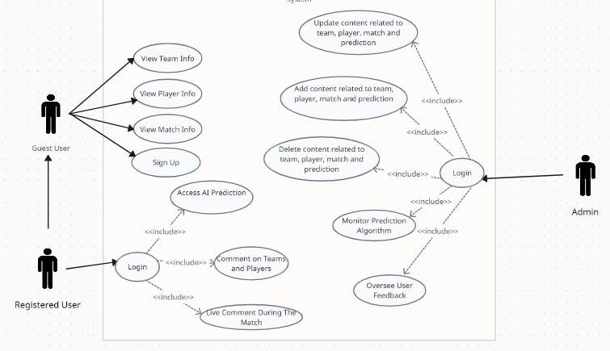

Figure 4. Use Case for the Users and Admin

1. **Sequence diagrams**

Sequence diagram will be shown in Figure 5. 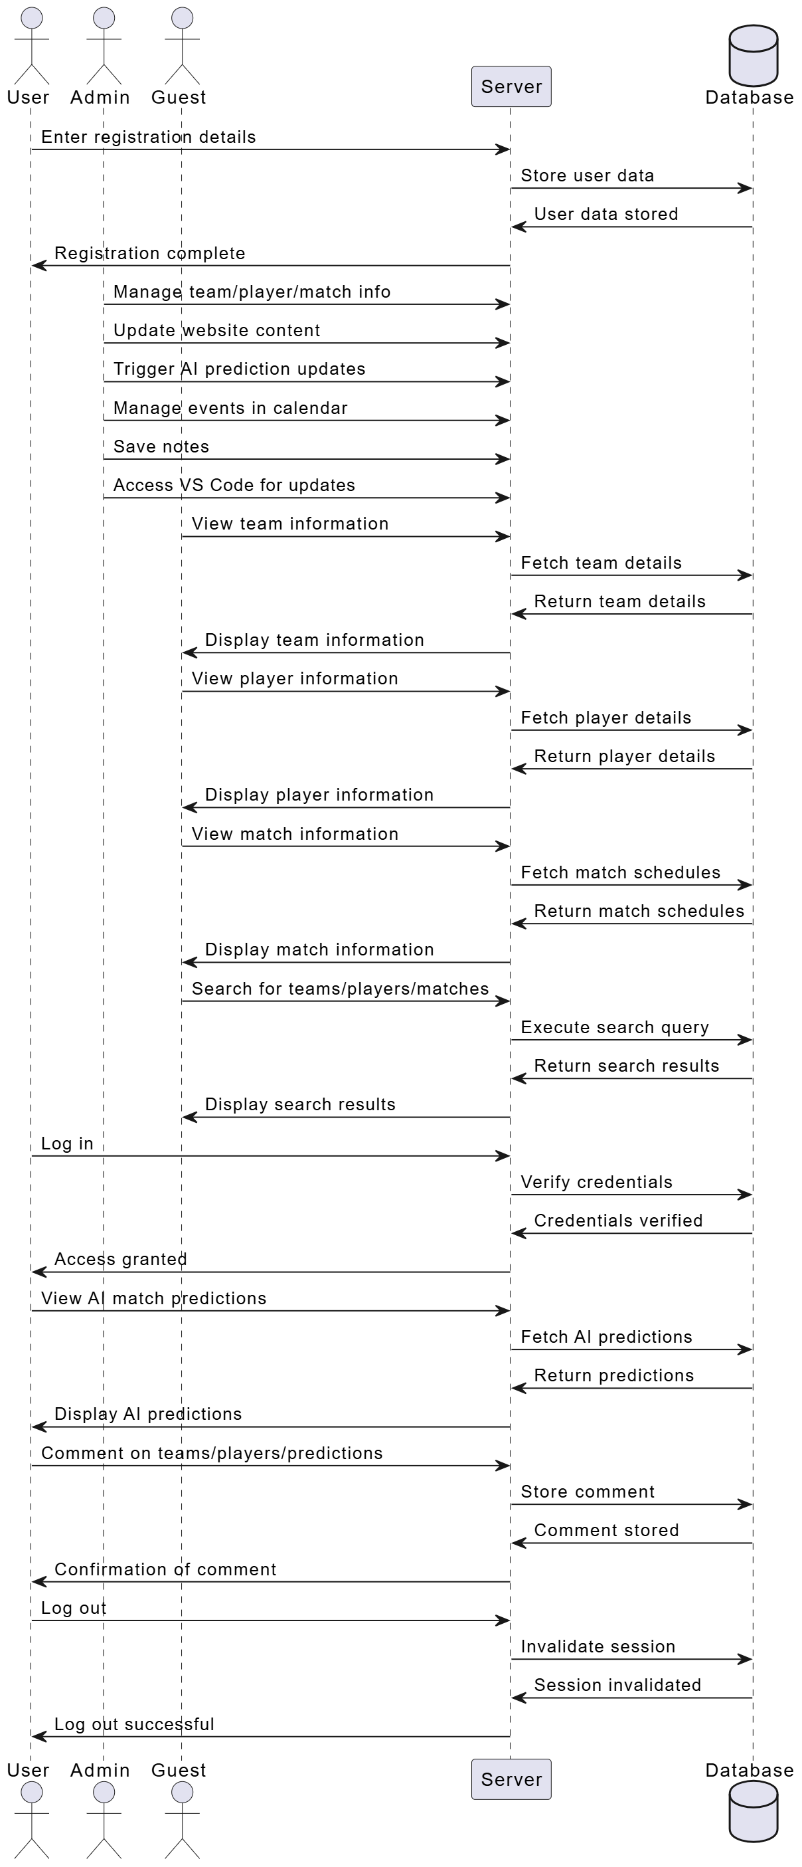

Figure 5. Sequence diagram 1

1. **Architecture of our Web App**

The Figure 7 demonstrates the architecture of our Web Application which is referred as a “React Firebase app” since this terminology captures the combination of the **frontend** framework which is **React.js** and the **backend** platform which is **Firebase** being used in the application.

### **Client-Side (Front-End):**

For the **client-side**, we use **React**, **HTML**, **CSS**, and **JavaScript** to build a responsive, dynamic, and highly interactive user interface. **React** is chosen for its component-based architecture, which allows for the efficient management of the complex user interface elements that display match predictions, player statistics, and real-time data updates. **HTML** and **CSS** are utilized for the structure and visual design of the website, ensuring compatibility across all devices and browsers. **JavaScript** enhances interactivity, enabling smooth user experiences such as form submissions, data fetching, and dynamic updates to the content. This combination of technologies guarantees that the platform provides a consistent user experience regardless of the device or browser being used.

### **Server-Side (Back-End):**

On the **server-side**, we rely on **Firebase** to manage all data operations and handle authentication. **Firebase Firestore** is used to store and retrieve dynamic data such as match predictions, player stats, and user-generated content (comments, rankings). The NoSQL nature of Firestore allows for flexible data storage, making it ideal for handling the variable and real-time data demands of the platform. **Firebase Authentication** is utilized for managing secure user authentication, ensuring that users can access their personalized content and interact with the platform safely. Additionally, **Firebase Storage** is used to manage media files, such as player images, team logos, and match visuals, ensuring quick and efficient content delivery.

React JS

Express

Web App Database

Firebase

HTML/CSS,

JavaScript

Front-end development Back-end development

Figure 6. Architecture of the Website

1. **Data Modelling**

Table 2. represents a clear overview of the advantages of NoSQL databases over relational databases, highlighting their flexibility, scalability, support for diverse data types, and consistent performance.

|  |  |
| --- | --- |
| Feature | Description |
| Flexible Schema | Firebase Firestore allows easy adjustments to data structures, ideal for evolving football data like player stats and match results. |
| Horizontal Scalability | |  | | --- | |  |  |  | | --- | | Firebase scales horizontally, handling increasing data volumes and user interactions as the platform grows. | |
| Support for various  Data Type | Firebase supports diverse data types such as JSON, making it suitable for complex, nested data like team profiles and predictions. |
| Consistent Performance | Firestore ensures real-time updates and maintains performance as the data grows, reflecting changes in player stats or predictions instantly. |

Table 2. Advantages of NoSQL databases

Figure 8 represents the tables for NoSQL database that contains the main functionalities used in the website and the dashboards.

|  |
| --- |
| Users |
| User-id |
| Email |

|  |
| --- |
| Notes |
| Note-id |
| Title |
| Details |

|  |
| --- |
| Teams |
| Team-id |
| Team-name |
| Year of foundation |
| History |
| President |
| Stadium |
| Stadium-description |
| Website |
| Instagram |
| Season |
| match played |
| Wins |
| Nb of trophy |
| Year of trophy |
| Image |

|  |
| --- |
| Players |
| Team-id |
| Player-id |
| name |
| number |
| Date of birth |
| height |
| weight |
| assists |
| foul |
| goals |
| Yellow cards |
| Red cards |
| substitution |
| Place of birth |
| penalty |
| minutes |
| Match played |
| start |
| shots |
| role |

|  |
| --- |
| Messages |
| Message-id |
| Sender-name |
| User-email |
| content |



|  |
| --- |
| Team Comments |
| Team-id |
| email |
| date |
| time |
| comment |
| Likes count |

|  |
| --- |
| Team replies |
| Comment-id |
| Email |
| Text |
| Created at |

|  |
| --- |
| player Comments |
| player-id |
| Email |
| Date |
| Time |
| Comment |
| Likes count |

|  |
| --- |
| Match |
| Id |
| Team1 |
| Team2 |
| Date |
| Time |
| Odds |
| Score |

|  |
| --- |
| Player replies |
| Comment-id |
| Email |
| text |
| Created at |

|  |
| --- |
| prediction Data |
| id |
| lives core |

Figure 7. Database collections with their documents

Figures 7 to 12show the schemas of our Collections in our Database.

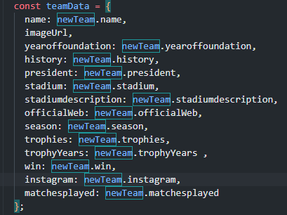

Figure 8. Team Collection

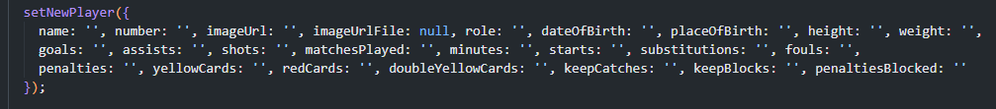

Figure 9. Player Collection

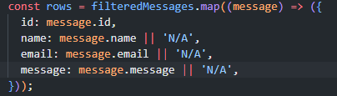

Figure 10. Messages

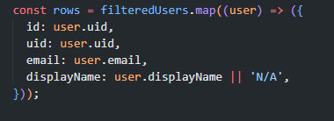

Figure 11. Users Collection

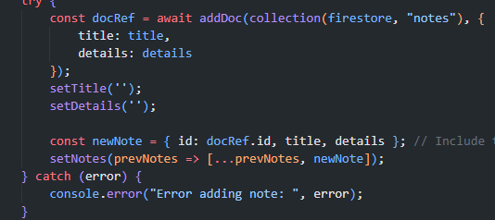

Figure 12. Notes Collection

1. **Technologies Used**

For the database, we are using **NoSQL Firebase** instead of an RDBMS due to its ability to handle large volumes of rapidly changing data and real-time updates, which are essential for a football prediction system. Firebase's flexible schema design allows seamless adaptation to evolving data structures, such as team statistics, match results, and user-generated content, without requiring significant modifications.

For the front-end, we utilized **ReactJS** due to its simplicity, performance, and ability to enhance user experience. React's component-based architecture allows the application to be structured like LEGO blocks, promoting modularity and maintainability. Additionally, React's virtual DOM dynamically updates only the parts of the page that have changed, leading to faster rendering and improved performance. Its balance of flexibility, scalability, and community support makes React an excellent choice for building modern and interactive web applications like the football prediction system.

1. **Conclusion**

In this chapter, the functional and non-functional requirements are described. Also, the use case and sequence diagrams are illustrated. In addition, the used platforms are described. The prediction analysis will be performed in Chapter 3.

**Chapter 3**

**Prediction model analysis**

* 1. **Introduction**

This chapter details the analysis, design, and implementation of an AI-driven football prediction model integrated into our system. Initially, we sought to create a forecasting model to predict future match outcomes. However, challenges with data limitations and inconsistencies led us to adopt a new approach focused on predicting match outcomes based on historical data. This chapter outlines the development of the prediction model, including feature engineering, model training, testing, and integration into the website.

* 1. **Transition from Forecasting to Prediction**

The initial plan was to build a forecasting model using chronological match data. However, the dataset we initially used lacked sufficient information to support reliable forecasting. Critical features that could influence match outcomes, such as team performance metrics and other contextual data, were either absent or inadequately represented. This limitation led to significant delays in the project timeline, with approximately two weeks spent attempting to process and analyze the initial dataset. After realizing the limitations, we decided to pivot to a new dataset containing detailed match statistics. This shift allowed us to focus on predicting match outcomes instead of attempting to forecast future games.

* 1. **Why use Decision Tree Algorithm**

**1-**Since is gave us the best accuracy (83.2%) between all other algorithms for example:

1. **KNN Classification**: 60% accuracy
2. **Random Forest Classifier**: 75.4% accuracy
3. **Grid CV**: 78.9% accuracy
4. **XG Boost**: 80.4% accuracy

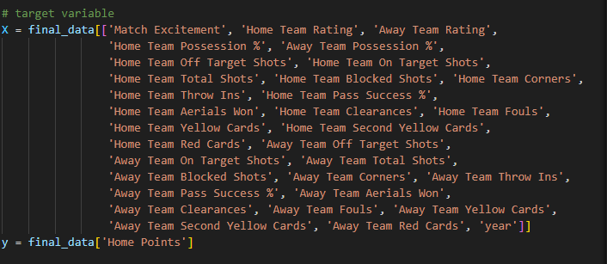 Figure 13. Final and Better Dataset

* 1. **Dataset and Feature Engineering**

We utilized a dataset spanning multiple La Liga seasons, from 2014 to 2020. This dataset included match scores, team statistics, and other performance metrics. Feature engineering was critical to extract meaningful information:

* **Feature Creation:** Using the match scores, we derived four key features:
  + **Home Team Goals Scored**
  + **Away Team Goals Scored**
  + **Home Team Goals Conceded**
  + **Away Team Goals Conceded**
* **Additional Features:** Metrics such as possession percentages, shot statistics, fouls, and yellow/red cards were included to provide a holistic view of team performance.
* **Target Variable:** The model was trained to predict the match outcome (win, draw, or loss) for the home team.

This new dataset provided the detailed insights necessary to build a reliable prediction model, helping us recover from the initial project delays.

* 1. **Model Selection and Training**

We selected a Decision Tree Classifier for its interpretability and suitability for categorical data. The training process involved:

1. **Data Splitting:** The dataset was divided into training and testing sets. Matches from 2014 to 2019 were used for training, while the 2020 season was reserved for testing.
2. **Hyper parameter Tuning:** Parameters such as tree depth and minimum samples per leaf were optimized to balance accuracy and generalization.
3. **Evaluation Metrics:** The model's performance was evaluated using accuracy, precision, recall, and F1-score.

**Results and Insights**

The final model achieved the following metrics on the testing set:

* **Accuracy:** 83.2%
* **Confusion Matrix:** Showed the distribution of correctly and incorrectly classified outcomes.
* **Training Accuracy:** 88.9%, indicating that no over fitting occurred.

The model demonstrated strong performance, particularly in predicting home wins, but highlighted areas for improvement in differentiating between draws and away wins.

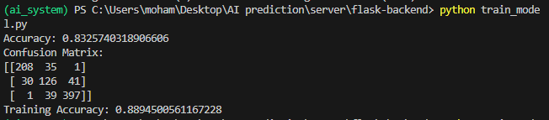

Figure 14. The model training and testing results

* 1. **Integration with the Website**

The model is integrated into the website backend to provide real-time predictions. The process includes:

1. Input Handling: Users provide match details, such as participating teams and key statistics.
2. Data Preprocessing: Inputs are processed to match the model's feature format.
3. Prediction: The model outputs the predicted result, displayed to the user.

This integration ensures seamless functionality, allowing users to access AI-driven insights at the click of a button.

* 1. **Conclusion**

This chapter highlighted the development of the AI model for match predictions, from initial challenges to successful implementation. The two-week delay due to an inadequate dataset underscores the importance of selecting the right data for machine learning projects. By leveraging historical data and advanced machine learning techniques, we created a robust system capable of providing valuable insights to football enthusiasts. This work demonstrates the adaptability required to address real-world challenges in AI-driven applications.

**Chapter 4**

**Implementation**

1. **Introduction:**

In response to the growing demand for advanced, user-focused football prediction platforms, our team embarked on the development of an innovative Football Prediction Website dedicated to La Liga. By integrating cutting-edge machine learning and predictive analytics, our goal is to deliver accurate match predictions and in-depth insights into teams, players, and upcoming games. We emphasize creating an interactive, easy-to-navigate experience that brings fans closer to the game.

Our website offers a unique platform where users can explore detailed statistics, gain insight into player and team performances, and access free, AI-driven match predictions with free registration. In addition to comprehensive data, our platform fosters user engagement by allowing fans to comment on predictions, share their thoughts, and interact with other football enthusiasts directly on the site.

Driven by collaboration and a commitment to continuous improvement, we aim to enhance the fan experience, offering reliable, transparent predictions and bringing La Liga closer to our users. Our mission is to make football analysis and prediction accessible, interactive, and accurate, meeting the evolving needs of football fans in the digital age.

1. **User Interface Description**
2. **Client Interface**

Figure 16 till 27 present the user interface of our website for our client interface. Figure 28 till 37 present the admin dashboard and interface

**Home page:** The homepage of the AI Soccer website greets users with a striking headline and a dynamic soccer-themed image, offering navigation to key sections like News, Clubs, and Contact, while prominently featuring a "Get Started" button for easy access to content. This setup highlights the focus on soccer and predictive analytics.

 Figure 15. Home Page

**Sign up page:** The sign-up page for AI Soccer features a registration form with fields for "Username," "Email," and "Password" against a background of a brightly lit soccer stadium, with easy navigation to Home, News, Clubs, About, and Contact sections. Existing users are prompted to log in, maintaining a user-friendly and engaging sports-themed design.

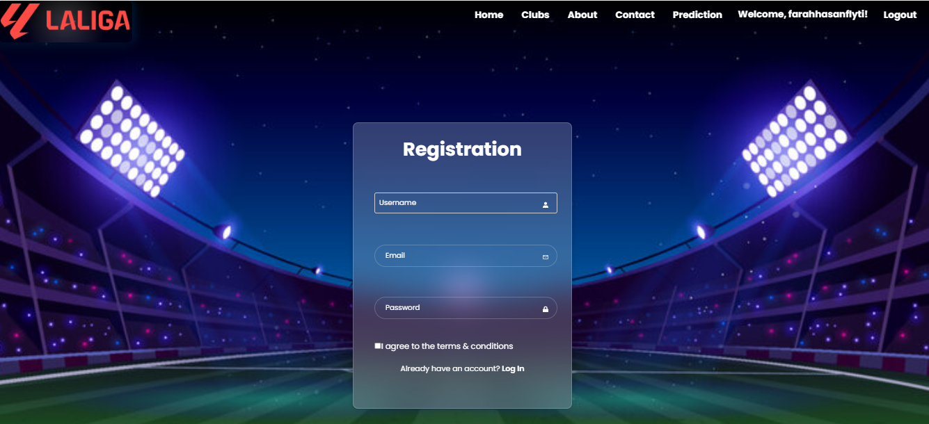

Figure 16. Create a New Account

**Login Page:** The login page for AI Soccer features a centered login form with fields for "Email" and "Password" against a backdrop of a brightly lit soccer stadium at night. It includes options for "Forgot password?" and a prompt for users to register if they don't have an account, ensuring easy navigation with links to Home, News, Clubs, About, Contact, and a "Guest" option.

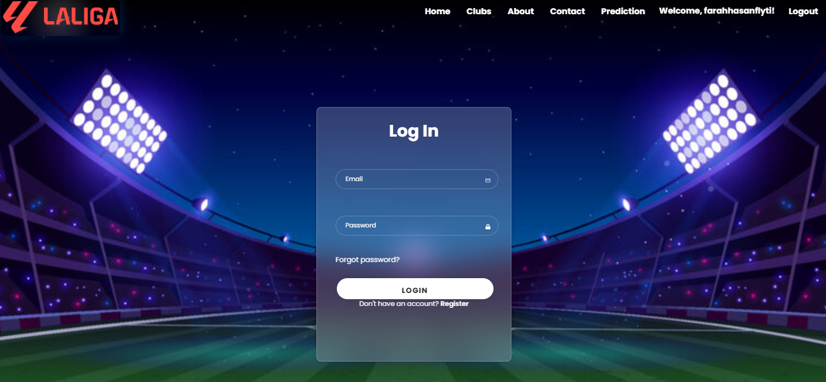

Figure 17. Login

**Forget password page:**

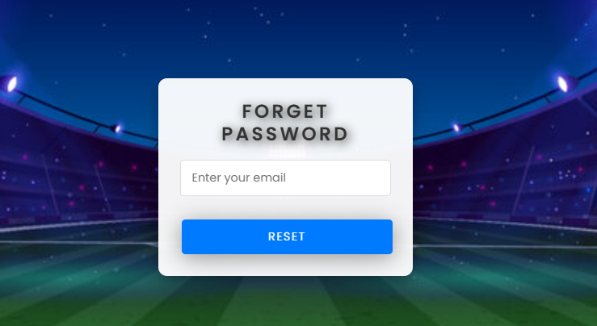 *Figure 18. Forget password*

Figure 20 presents what is inside the book reservation page, in addition to the filtering section that in this example we wrote the word “the” and several options appeared in the search input.

**Contact Page:** The "Contact Us" page on AI Soccer Pro features a visually appealing stadium backdrop with bright lights, reflecting the sports theme. It includes essential contact information such as the address (4567 Main Road, Beirut, Lebanon), phone number (4567889), and email (usersaffairs@gmail.com). Additionally, there's a user-friendly form on the right side for visitors to send messages, including fields for full name, email, and message, along with a "Send" button. This design ensures that users can easily reach out with their inquiries or feedback.

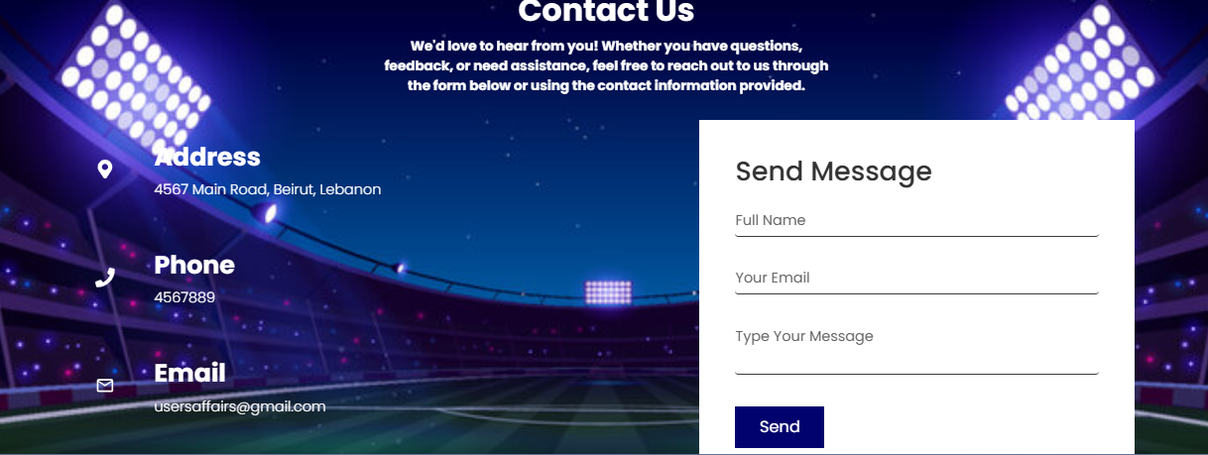

Figure 19. Contact Page

Figure 20 shows the reply messages between the chatbot and the guest user, suggesting some books for the user and assisting them with their requests and desires.

**Club Page:** the AI Soccer Pro website features a section dedicated to La Liga teams. This section provides detailed information about various clubs, including their names, logos, foundation years, and links to view more details about each team2. It's a great resource for fans who want to learn more about their favorite La Liga teams!

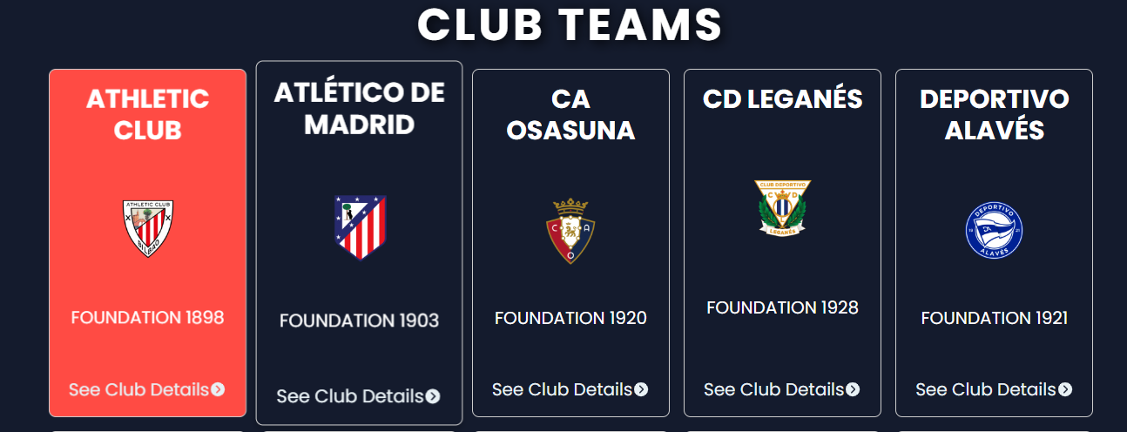

Figure 20. Club Page

Figure 21 represents the details and information about a specific chosen book for the user that just logged in for having title of the book, author name, description of the book, genre, language written, total number of pages, and if the book is available or not with a note written in red color.

**Club Details:** The club details pages on AI Soccer Pro provide comprehensive information about each La Liga team. These pages feature the club's logo, foundation year, president, stadium, official website, and social media links. They include the number of trophies won and a dropdown menu listing the years of these achievements. Additionally, the pages offer tabs for detailed insights into the club, including its squad, upcoming matches, results, and statistics, giving fans a thorough overview of their favorite teams.

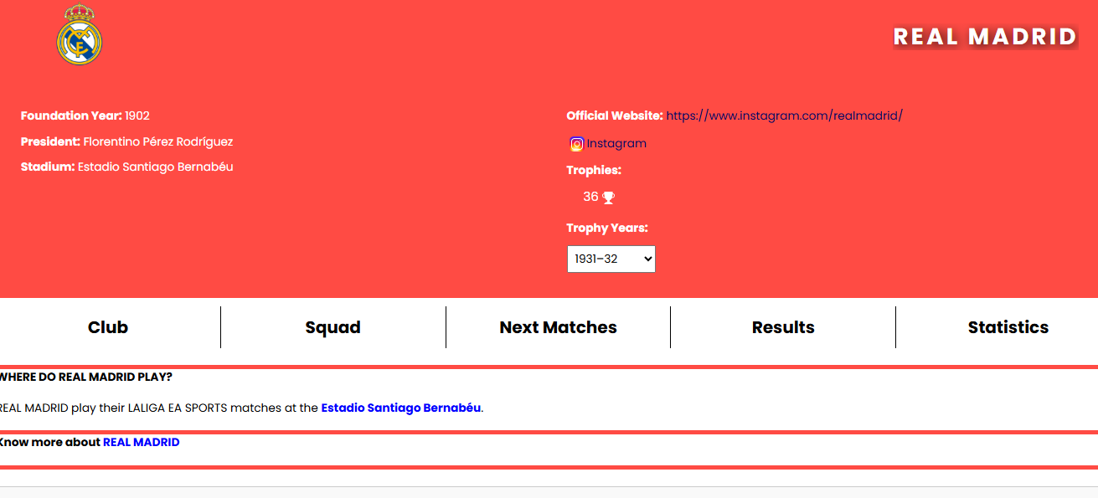

Figure 21. Club Details

Squad Page: The squad page on AI Soccer Pro provides detailed information about each player on the team. It features sections for different player positions such as goalkeepers, defenders, midfielders, and forwards. Each player is listed with their name, jersey number, and photo, along with additional details such as their role, date of birth, place of birth, height, weight, goals, and assists. the squad page on AI Soccer Pro includes a convenient search feature that allows fans to quickly find players by name. This setup allows fans to easily learn about the individual players and their contributions to the team.

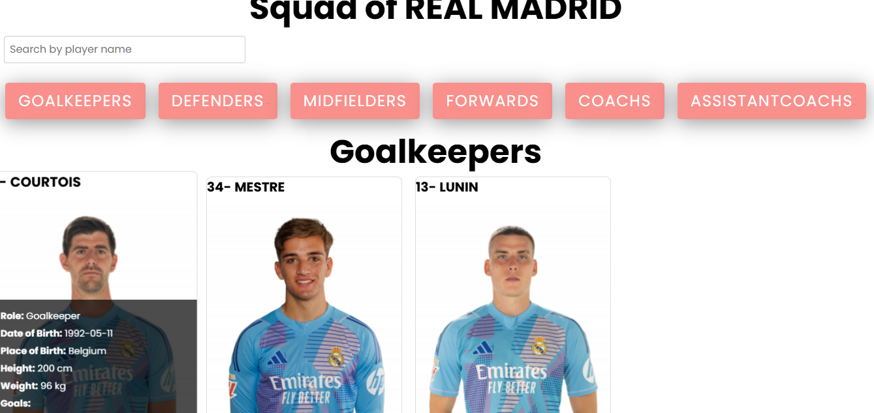

Figure 22. Squad Page

**Player Profile:** The player profile page on AI Soccer Pro provides comprehensive information for each footballer, including personal details like name, position, date of birth, height, and weight. It also includes performance statistics such as goals, assists, shots, matches played, minutes, starts, substitutions, fouls, penalties, yellow cards, and red cards, offering fans a detailed overview of their favorite players' careers and contributions.

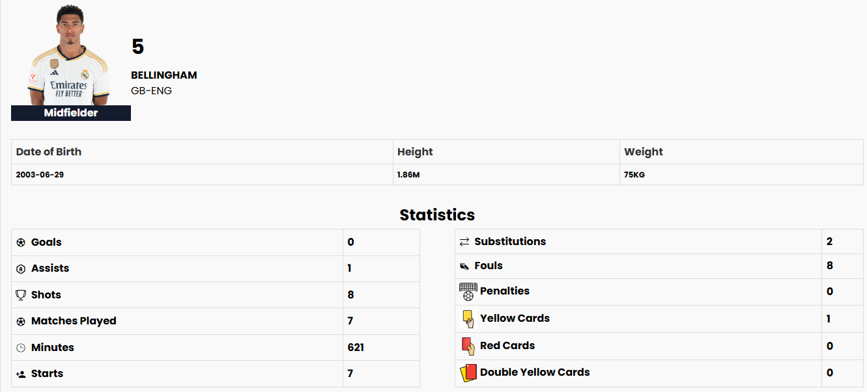

Figure 23. Player Profile

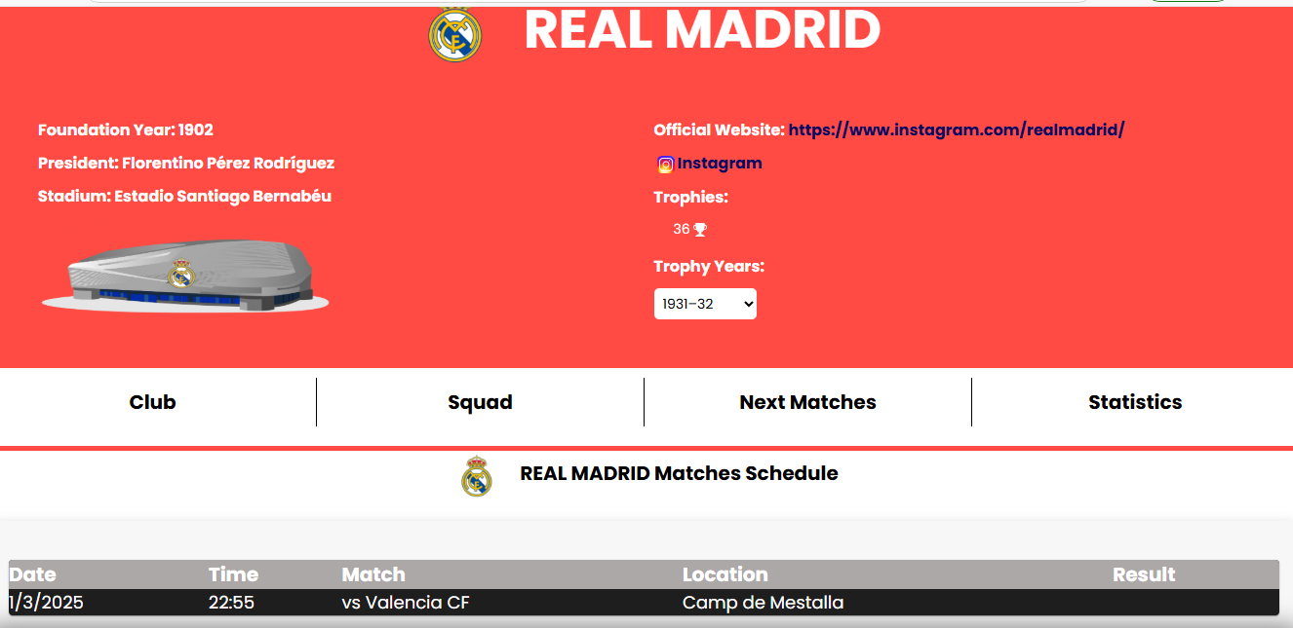

Figure 24. Match Page

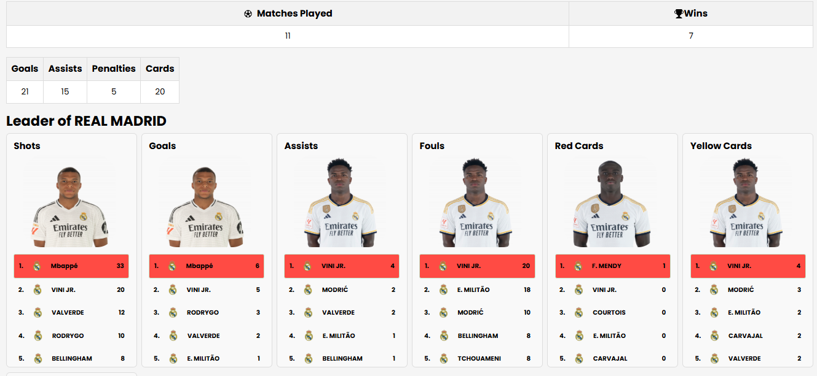

Figure 25. Statistics Page

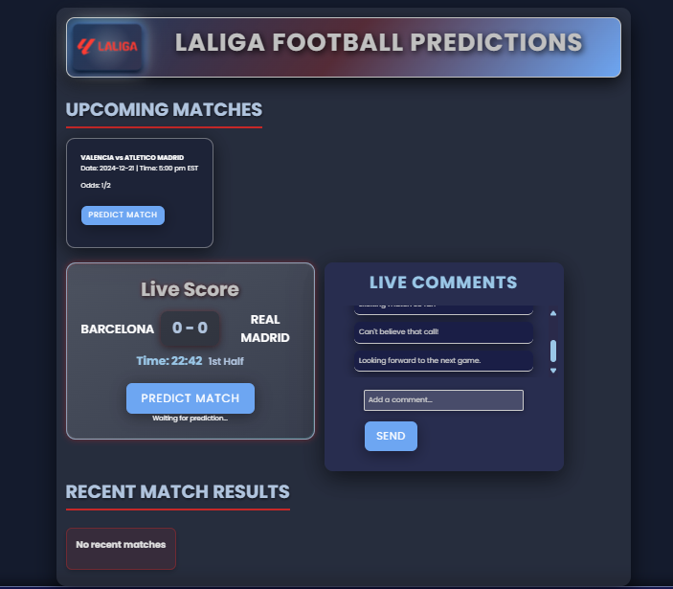

Figure 26. Prediction Page

**About Us Page**: The "About Us" page of AI Soccer Pro introduces the platform as a passionate blend of football and advanced technology, aimed at enhancing the experience for fans worldwide. It outlines the company's mission to provide accurate football predictions through cutting-edge machine learning algorithms and presents a vision of revolutionizing fan engagement with the sport, emphasizing accuracy, reliability, and innovation.

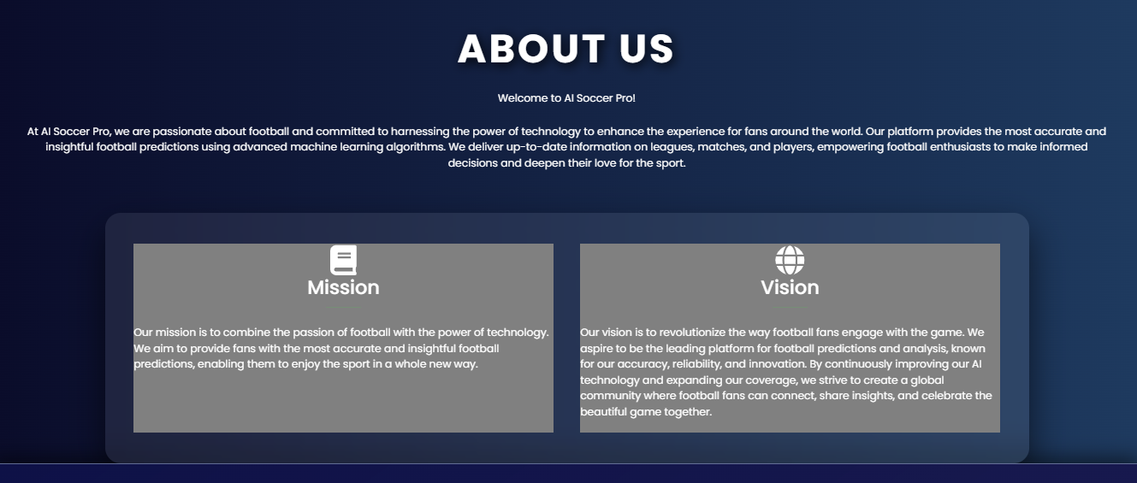

Figure 27. About us Page

1. **Admin Dashboard and Interface**

**Admin Dashboard:** The admin dashboard on AI Soccer Pro provides a user-friendly interface for managing various aspects of the application, including Users, Leagues, Teams, Matches, Feedback, Web Team, Calendar, and Settings. Each section is accessible through colorful buttons and icons, facilitating efficient administration.

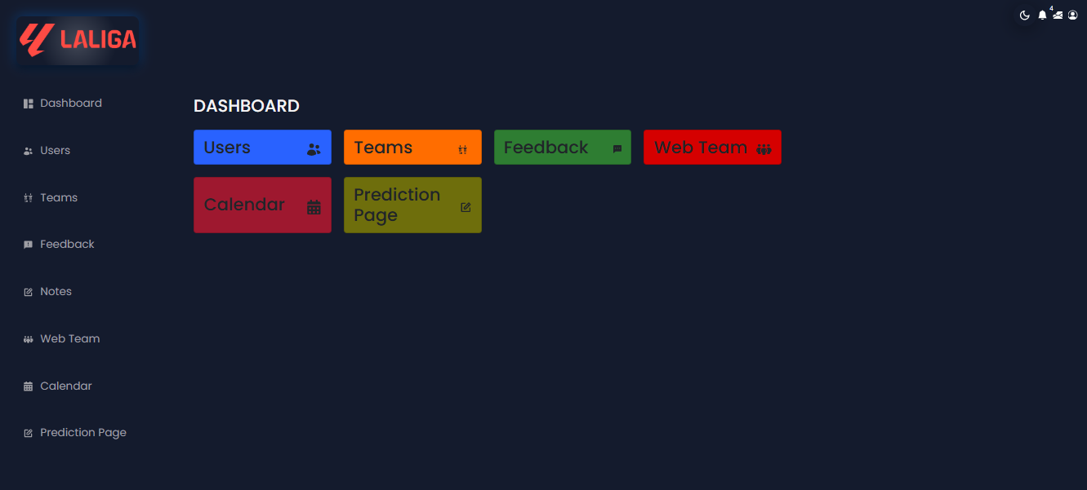

Figure 28. Admin Dashboard

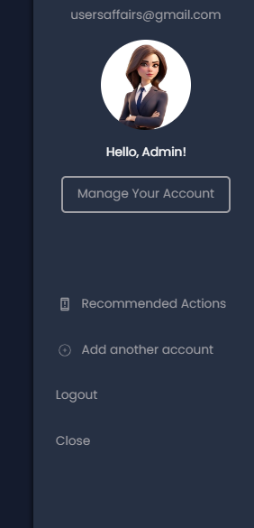

Figure 29. Admin Profile

**User Management Page:** The user management page on AI Soccer Pro features a search bar at the top labeled "Search by email..." and a table displaying user details including UID, email, and display name. Administrators can select users via checkboxes, navigate through different pages, and adjust the number of rows displayed per page for efficient user management.

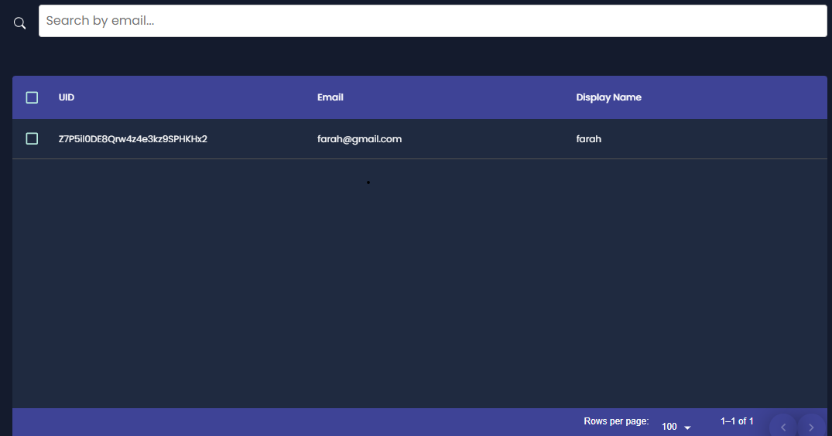

Figure 30. User Page

**Team Management Page:** The team management page on AI Soccer Pro allows administrators to add and manage team details through a comprehensive form. This form includes fields for entering information like the team name, year of foundation, history, president, stadium details, official website, social media links, and performance statistics. Additionally, there are options to add new teams, display all existing teams, and upload files, ensuring efficient and detailed team management.

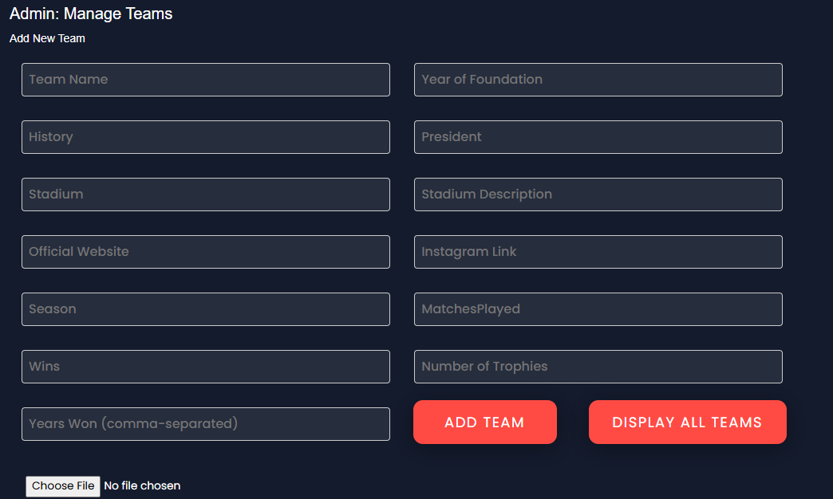

Figure 31. Team Management Page

**Player Management Page:** The player management page on AI Soccer Pro provides a comprehensive form for entering and managing player details. It includes fields for player name, number, role, date of birth, place of birth, height, weight, and various performance statistics such as goals, assists, shots, matches played, minutes, starts, substitutions, fouls, penalties, yellow cards, and red cards. Administrators can add new players, display the list of existing players, and upload files, ensuring efficient and detailed player management.

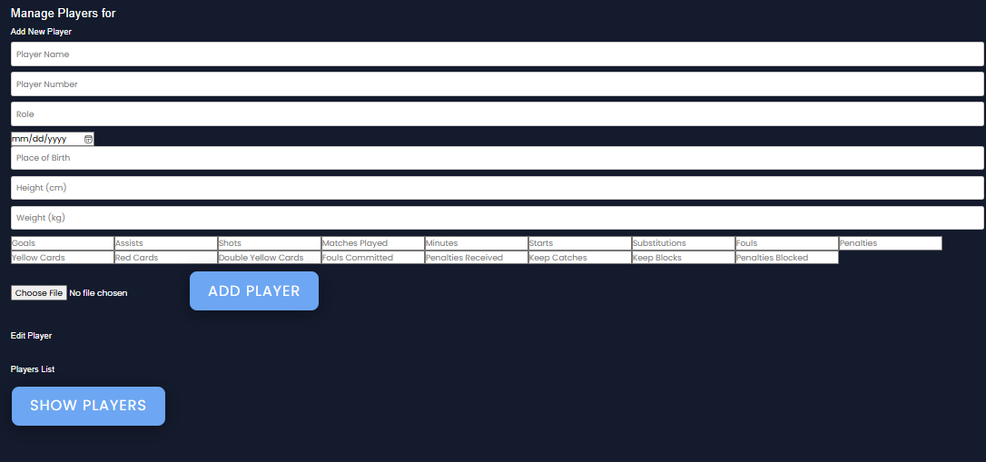

Figure 32. Player Management Page

**Feedback Page:** The feedback page on AI Soccer Pro features a table listing feedback entries, each with columns for ID, Name, Email, Message, and Action. A search bar at the top allows administrators to search feedback by email, and each entry in the Action column includes a "DELETE" button for managing feedback efficiently.

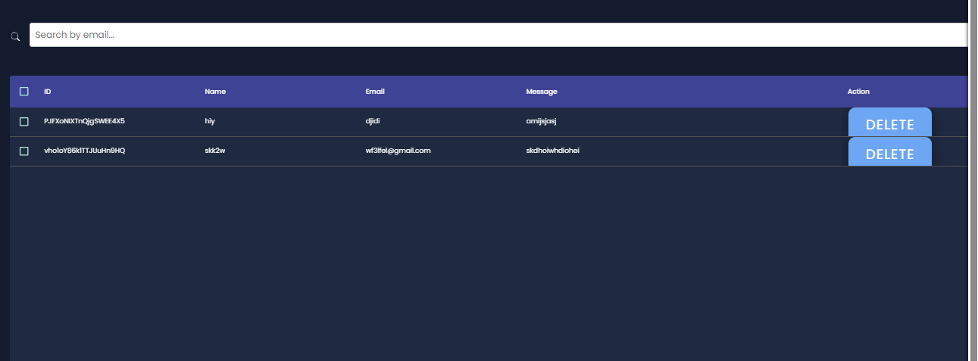

Figure 33. Feedback Page

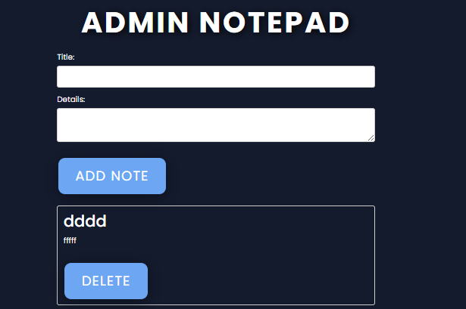

Figure 34.Admin Notepad

Figure 35 presents an email notification from the admin to the user that reserved a book, reminds him/her about their due date of returning the book they have got.

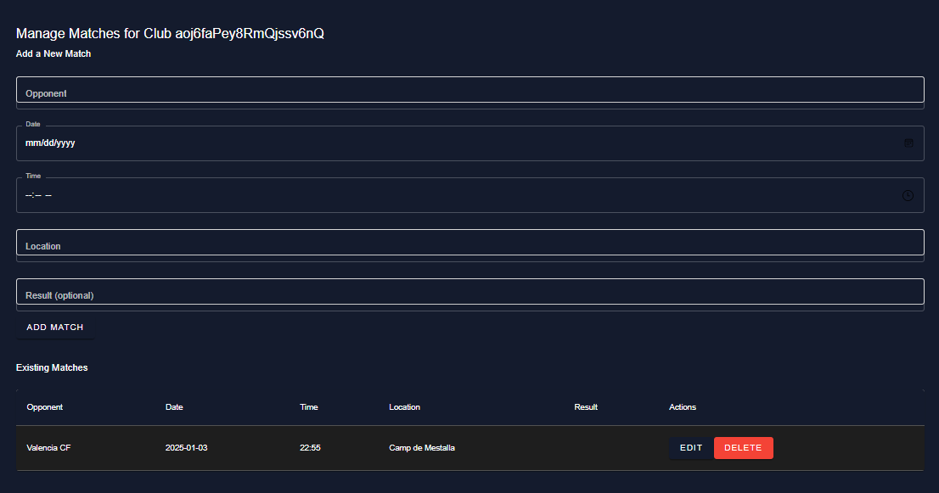

Figure 35. Match management Page

**Calendar Page:** The calendar page on AI Soccer Pro features a digital monthly calendar with days labeled from Sunday to Saturday. It allows users to navigate between months, view events in different formats (month, week, day, or list), and highlights specific events on their corresponding dates, providing a clear and organized view of upcoming activities. For example, it includes an "Events" section on the left side for easy reference to listed events.

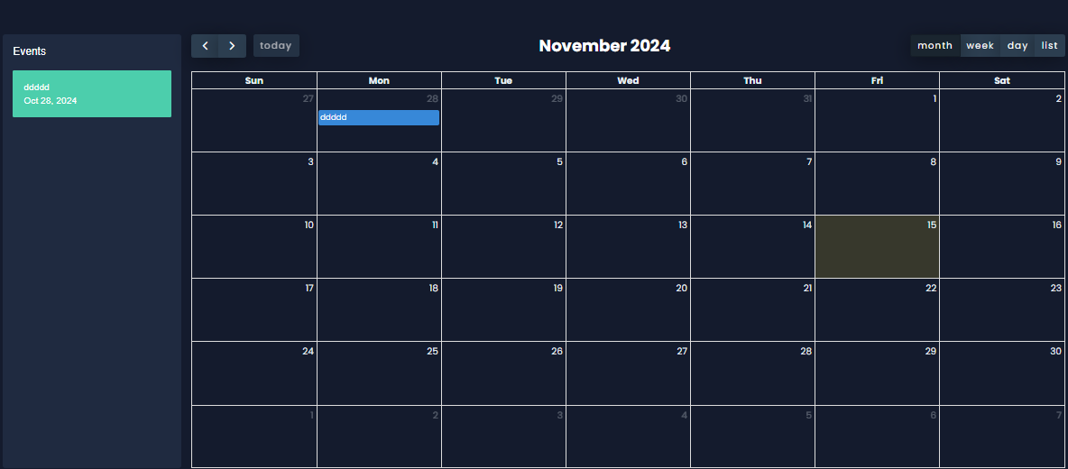

Figure 36. Calendar Page

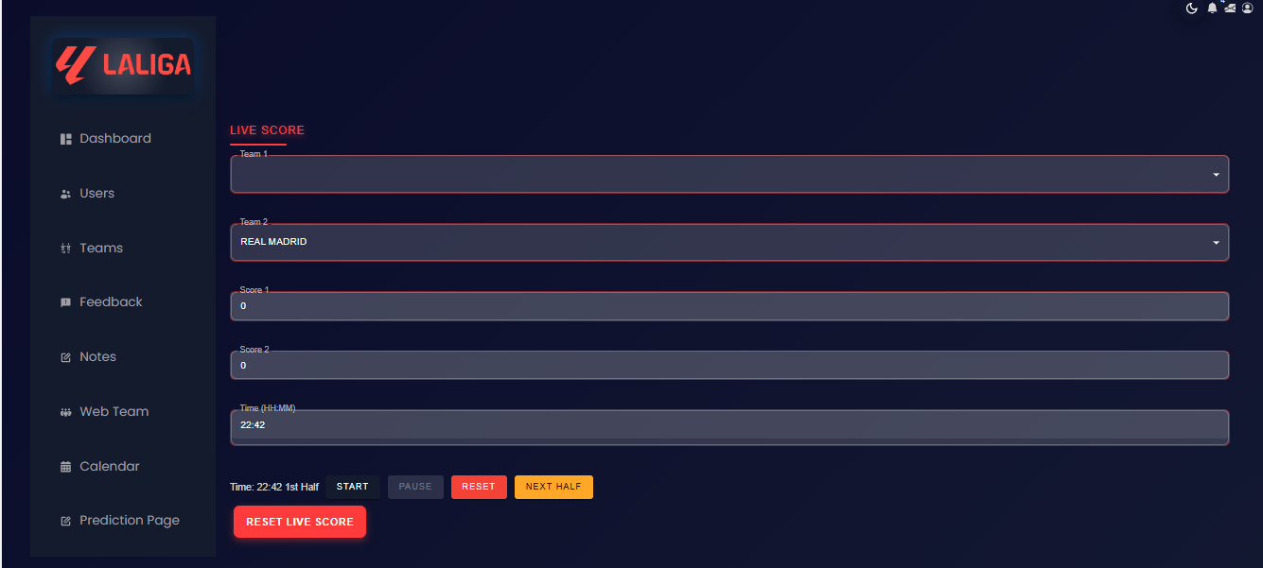

Figure 37. Prediction Management Page

**Chapter 5**

**Usability Assessment**

1. **Introduction**

In order to evaluate our football prediction system, a survey-based assessment technique will be adopted. For this reason, a satisfactory usability assessment survey composed of 11 questions were built. A full version of this survey is presented in appendix A. In this chapter, a discussion of the survey results will be performed. This chapter is composed of three main Section. The sample adopted in this report will be described in Section II. The discussion of the answers of the survey will be performed in Section III. This chapter will conclude in Section IV.

1. **Sample**

A total of 11 volunteers has participated in assessing the usability of the library management website. Age, gender and profession distributions are presented in Figures.

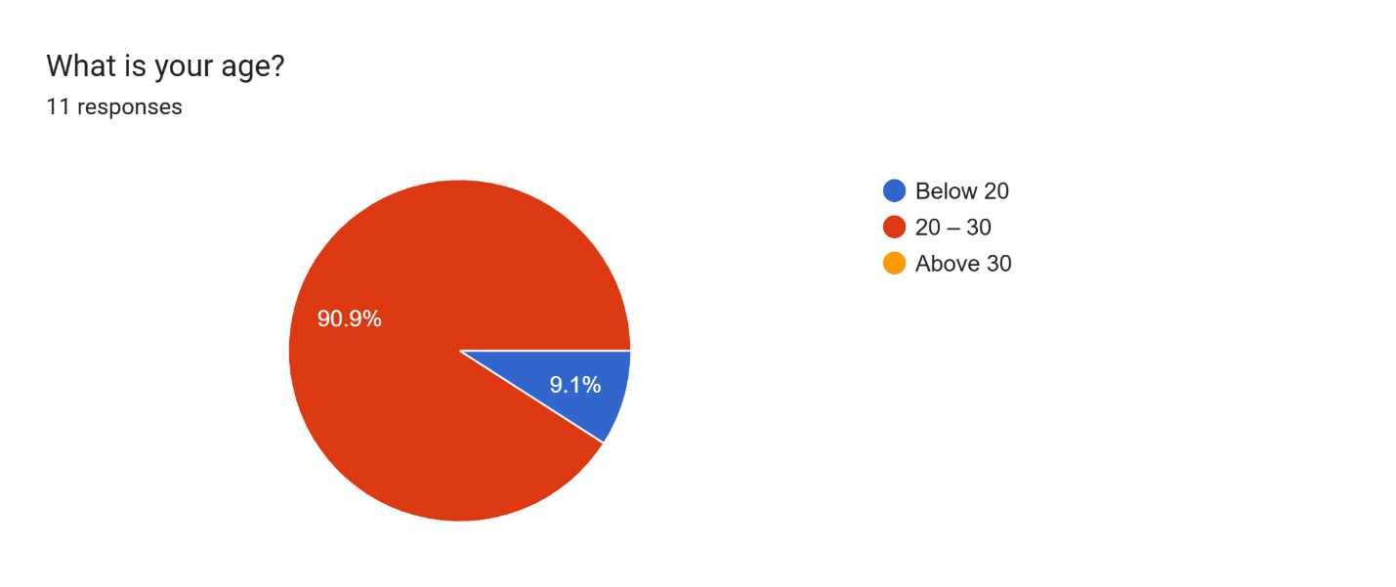

Figure 38. Age

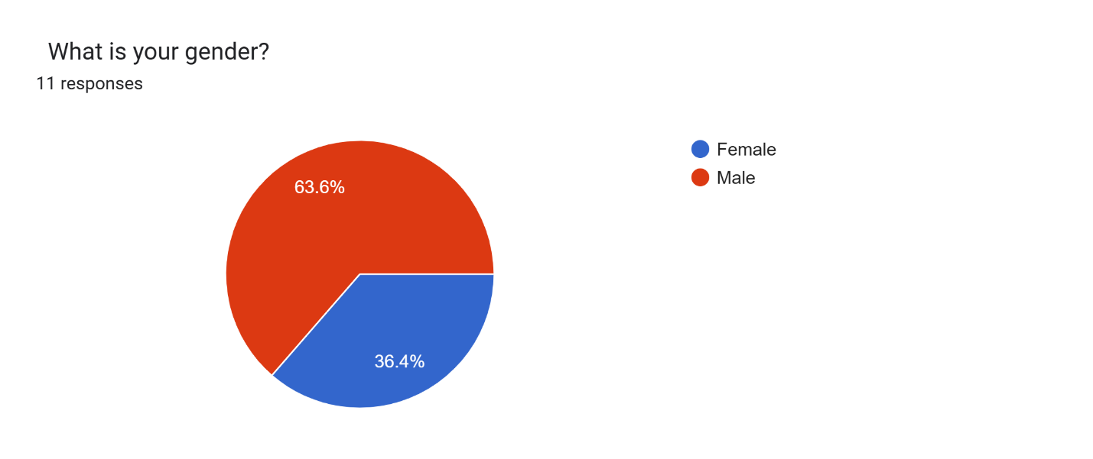

Figure 39. Gender

As illustrated in figure 37, only 0% of the sample are older than 30. This is normal as the survey was distributed in the RHU and most of the society are undergraduate students.

Figure 38 indicates that the sample is predominantly male, with 63.6% identifying as such, while 36.4% are female. This distribution is typical for a football website, reflecting the sport's traditionally male-dominated fan base. For instance, in the United States, 70% of American males engage with the NFL, compared to 53% of American females.

Figure 16 illustrates the professional composition of the sample: 18.2% are workers, which may include university staff, school teachers, or other professionals with an interest in football. The remaining 81.8% are students, who often follow football both as a leisure activity and a passion.

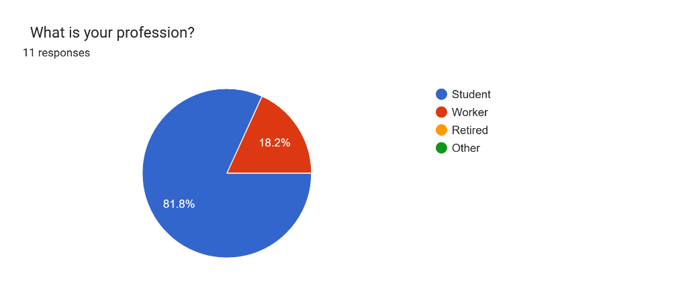

Figure 40. Profession

1. **Result of the survey**

In this section, a discussion of the survey answer will be performed. Figure 41 shows the answer of the item: “I can easily navigate within the website”. As illustrated in this figure, the answers were distributed between Agree and strongly agree. Thus, the navigation in the proposed football prediction system is simple and easy as shown in figure 18 also with 81% of quickness.

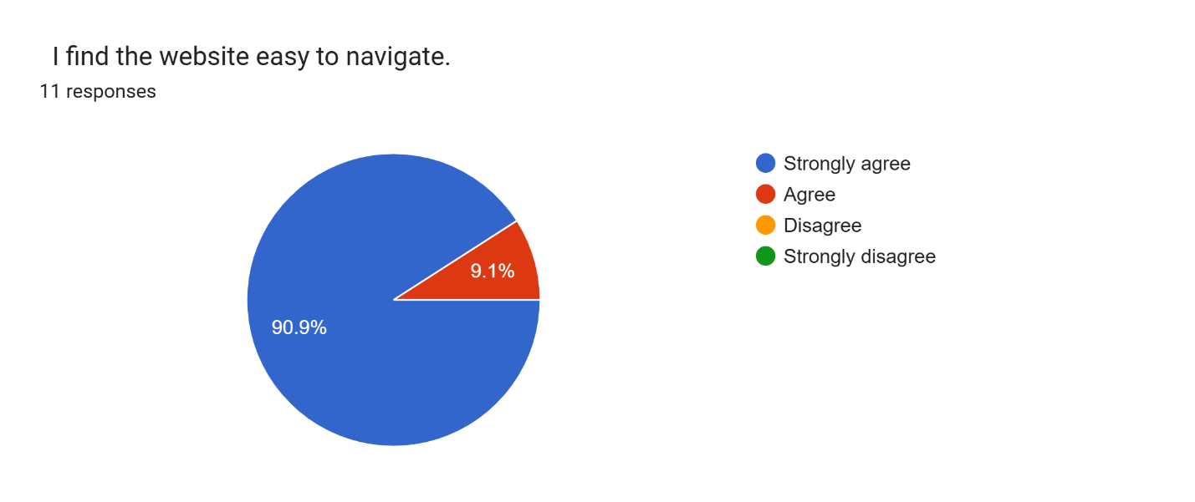

Figure 41. Navigation within the Website

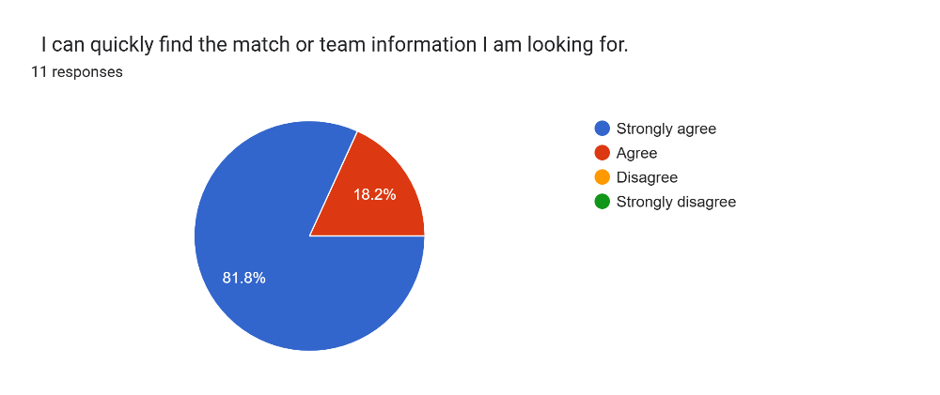

Figure 42. Easiness and Quickness

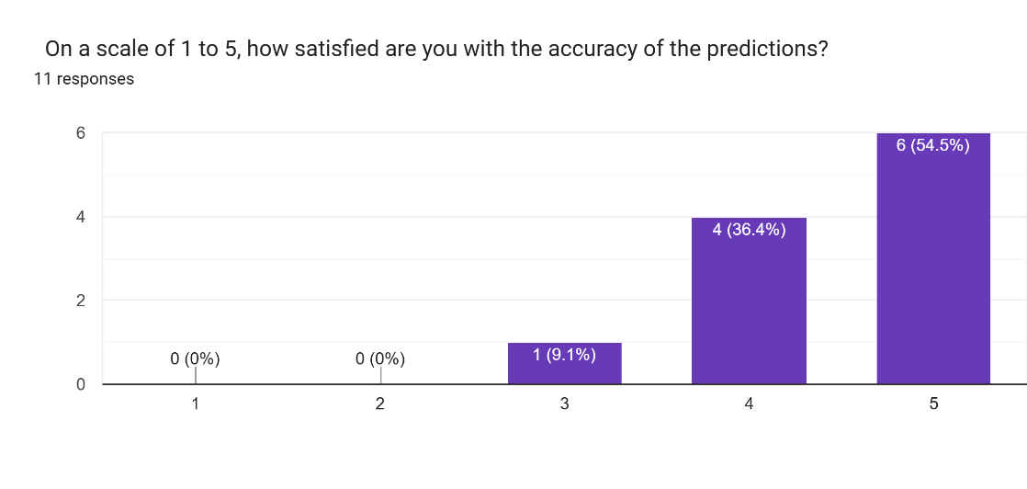

Figure 43. Satisfaction

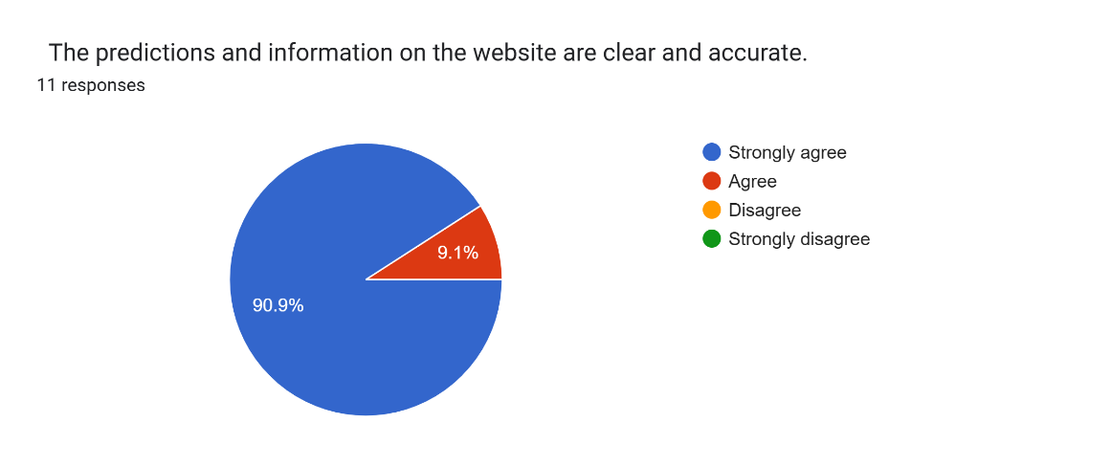

Figure 44. Clear Information

 What additional features would you like to see added to the football prediction system?

11 responses

* A comparison tool to analyze the performance of two players from different teams based on their statistics, such as goals, assists, passes, and other key metrics.
* No
* Prediction at what minute the player score.
* I would like news to be added
* add favorite player and team
* Football news and updates
* To put highlights to each player
* A new section would be useful
* News and highlights

Figure 45. Suggestion

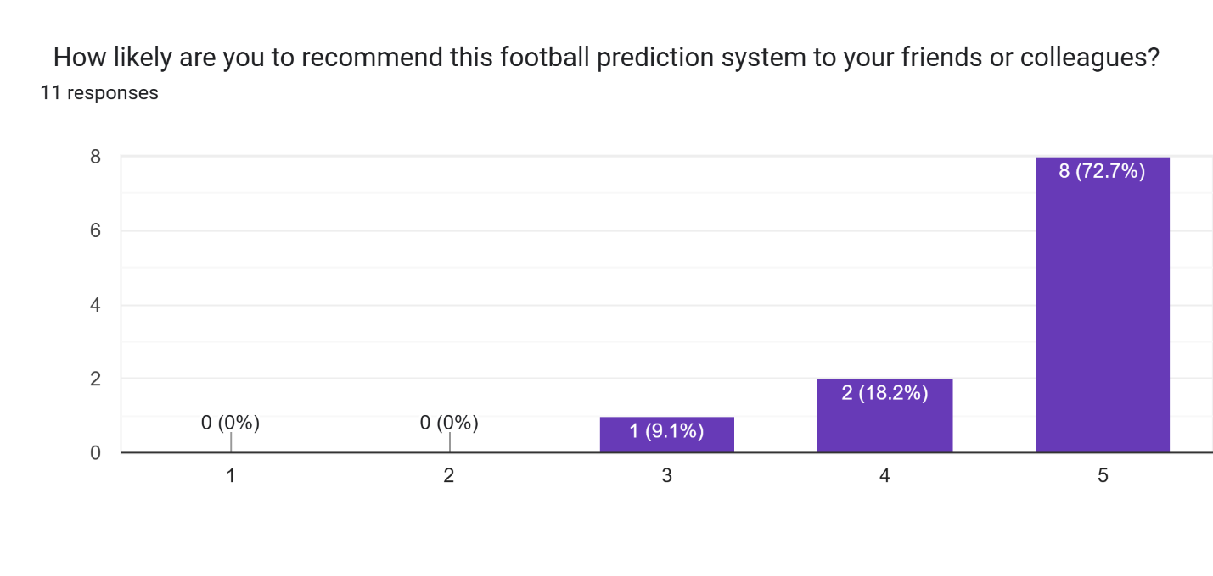

Figure 46. Recommendations

Table 3. represents a clear overview of the information and percentages that resulted from our survey done above, with brief words that define our questions and their below options as well as the number of percentages every option has obtained after collecting them from the participants.

|  |  |  |  |  |  |
| --- | --- | --- | --- | --- | --- |
| Questions | Option 1 | Option 2 | Option 3 | Option 4 | Option 5 |
| Age | Below 20 (9.1%) | 20-30 (90.9%) | Above 30  (0%) | - | - |
| Gender | Female (36.4%) | Male (63.6%) | - | - | - |
| Profession | Student (81.8%) | Worker (18.2%) | Retired (0%) | Other  (0%) | - |
| Navigation | Strongly agree (90.9%) | Agree (9.1%) | Disagree (0) | Strongly disagree (0) | - |
| Easiness & quickness | Strongly agree (81.8%) | Agree (18.2%) | Disagree (0) | Strongly disagree (0) | - |
| Satisfaction (rate) | 1 (0%) | 2 (0%) | 3 (9.1%) | 4 (36.4%) | 5 (54.5%) |
| Clear Information | Strongly agree (90.9%) | Agree (9.1%) | Disagree (0%) | Strongly disagree (0) | - |
| use the prediction feature to forecast match outcomes | Always (27.3%) | Often (45.5%) | Sometimes (18.2%) | Rarely (9.1%) | Never (0%) |
| website's design and layout visually appealing and easy to interact | Yes (100%) | No | - | - | - |
| Recommendation (rate) | 1 (0%) | 2 (0%) | 3 (9.1%) | 4 (18.2%) | 5 (72.7%) |

Table 3. Results of our Survey

1. **Conclusion and Discussion**

After gathering feedback from our users, we’ve analyzed their responses to assess the effectiveness and user experience of our football prediction system. We are pleased to report that the system has been well-received, with the majority of users praising its ease of use, the accuracy of predictions, and the intuitive design of the platform.

Approximately 90% of respondents expressed satisfaction with the accuracy of the predictions, while 90% indicated they would recommend the system to their friends and colleagues, marking a strong positive response from our user base. Furthermore, around 72% of participants mentioned they frequently use the prediction feature to forecast upcoming match outcomes, suggesting that the system is providing value to regular users.

We also gathered several suggestions for new features that would further enhance the user experience:

* A comparison tool to analyze the performance of two players from different teams based on their statistics, such as goals, assists, shots, and other key metrics.
* A prediction feature for predicting the exact minute a player will score.
* Adding a section for football news and updates.
* The ability to add and track favorite players and teams.
* Providing player highlights to improve user engagement.
* Introducing a section for user-submitted suggestions to improve the system.

These suggestions are valuable and will be considered for future updates to improve the overall functionality and appeal of the system.

**Conclusion and Perspectives**

In conclusion, the development of our Football Prediction System represents a significant step forward in using technology to enhance the football fan experience. With a focus on accuracy, real-time predictions, and user-friendly design, our platform aims to provide football enthusiasts with valuable insights and predictions about upcoming matches. The system integrates cutting-edge technologies such as machine learning algorithms, React.js for the frontend, and Flask for the backend to ensure an efficient, scalable, and responsive user experience.

The use of a decision tree model for match outcome predictions, combined with advanced features like team and player statistics, enables the system to generate precise forecasts. By continuously analyzing and processing historical data, the model provides reliable predictions based on team performance, player statistics, and other relevant factors. Additionally, the user interface is designed to be intuitive, with clear and concise match predictions and an easy-to-navigate layout for users to access essential features like team information, match schedules, and more.

As we move forward, we plan to enhance the system with several key features based on user feedback. These include the addition of a comparison tool for player statistics, the ability to predict the exact minute a player will score, and a section dedicated to football news and updates. The ability for users to track their favorite teams and players will also be implemented, creating a more personalized experience. Furthermore, adding highlights for players will provide a richer understanding of their performances, improving overall

**APPENDIX A**

**Questionnaire**

Dear Participant,

You are invited to contribute in a survey, titled “User Feedback Survey for the Football Prediction Website”. The survey is being directed our final year project (Summative Learning experience (COSC 490)) at Rafik Hariri University.

Our purpose is to examine the satisfaction and the ease of use of our website. Your participation in the survey will help us improve our aim of the website and make it more user friendly. We assess that it will take about 3 to 4 minutes of your time to complete it.

All measures have been taken to protect your identity. The surveys’ question does not ask to reveal any personal information.

Your contribution in this questionnaire is voluntary. You may not answer to any question, and you can withdraw from answering at any time.

If you have any questions or would like to comment, please contact us.

Sincerely,

Farah Flity

Ahmad Maarouf

Mhamad Miri

Sami Shehade

**Questionnaire**

1. What is your age?
2. Below 20
3. 20 – 30
4. Above 30
5. What is your gender?
   1. Female
   2. Male
6. What is your profession?
   1. Student
   2. Worker
   3. Retired
   4. Other
7. I find the website easy to navigate.
   1. Strongly agree
   2. Agree
   3. Disagree
   4. Strongly Disagree
8. The predictions and information on the website are clear and accurate.
   1. Strongly agree
   2. Agree
   3. Disagree
   4. Strongly Disagree
9. I can quickly find the match or team information I am looking for.
   1. Strongly agree
   2. Agree
   3. Disagree
   4. Strongly Disagree
10. On a scale of 1 to 5, how satisfied are you with the accuracy of the predictions?

* Scale from 1 to 5

1. How often do you use the prediction feature to forecast match outcomes?
   1. Always
   2. Often
   3. Sometimes
   4. Rarely
   5. Never
2. What additional features would you like to see added to the football prediction system?
3. Do you find the website's design and layout visually appealing and easy to interact with?
   1. Yes
   2. No
4. How likely are you to recommend this football prediction system to your friends or colleagues?

* Scale from 1 to 5

**References**

[1] Best Football Prediction Site &amp; Betting Tips. (2024). Tips 180.

<https://tips180.com/>

[2] LALIGA official website. (2024). LA Liga.

<https://www.laliga.com/en-LB>

[3] The official website for European football. (2024). UEFA.

<https://www.uefa.com/>

[4] Naik, S. S. (2024). *La Liga match data*. Kaggle. <https://www.kaggle.com/datasets/sanjeetsinghnaik/la-liga-match-data/data>

[5] Naik, S. S. (2024). *La Liga match data: Code*. Kaggle. <https://www.kaggle.com/datasets/sanjeetsinghnaik/la-liga-match-data/code>

[6] Smith, J., & Lee, K. (2023). *Football match prediction using machine learning techniques*. Journal of Sports Analytics, 14(2), 112-125. <https://www.examplejournal.com/football-prediction-ml>

[7] Jones, P. R. (2022). *Sports analytics: A guide to data-driven football predictions*. Springer. <https://www.springer.com/sports-analytics-football>

[8] Quinlan, J. R. (1986). *Induction of decision trees*. Machine Learning, 1(1), 81-106. <https://link.springer.com/article/10.1007/BF00116251>

[9] Breiman, L., Friedman, J. H., Olshen, R. A., & Stone, C. J. (1986). *Classification and regression trees*. Wadsworth & Brooks/Cole. <https://www.springer.com/gp/book/9781482253056>

[10] Han, J., Kamber, M., & Pei, J. (2011). *Data mining: Concepts and techniques* (3rd ed.). Elsevier. <https://www.elsevier.com/books/data-mining/han/978-0-12-381479-1>

[11] SponsorPulse. (2023, February 24). NFL fan demographics: Who is football's biggest fans? <https://www.sponsorpulse.com/insights/nfl-fan-demographics-who-are-footballs-biggest-fans>

[12] Gotterbarn , D., Brinkman, B., Flick, C., Kirkpatrick, M., Miller, K., Varansky, K., Anderson, E., Anderson, R., Bruckman, A., Carter, K., Davis, M., Duquenoy, P., Epstein, J., Kimppa, K., Kisselburgh, L., Kumar, S., McGettrick, A., Milic-Frayling, N., Oram, D., … Waguespack, L. (2018b, June 22). The code affirms an obligation of computing professionals to use their skills for the benefit of society. Code of Ethics.

<https://www.acm.org/code-of-ethics>

# **Appendix**

**ACM Code of Ethics and Professional Conduct**  
The ACM Code of Ethics and Professional Conduct has been adhered to during the development of this football prediction system. Below are the key guidelines from the ACM Code of Ethics and Professional Conduct applied throughout this project:

***1. GENERAL ETHICAL PRINCIPLES.***

A computing professional should...

1. Contribute to society and to human well-being, recognizing that all people, including football fans, stakeholders in sports analytics and technology, are impacted by the outcomes of this system.
2. Avoid harm by ensuring that predictions and insights do not mislead users or result in negative consequences for the football community.
3. Be honest and trustworthy in all data handling, especially when gathering and processing player and team information.
4. Be fair and take action not to discriminate by ensuring that the prediction system and its features do not favor one team, player, or group over another.
5. Respect the work required to produce new predictions, algorithms, and features, acknowledging contributions to football analytics and technology.
6. Respect user privacy by ensuring that personal data used for prediction or recommendation purposes is stored securely and with user consent.
7. Honor confidentiality when handling sensitive user data, including player statistics and match data.

***2. PROFESSIONAL RESPONSIBILITIES.***

A computing professional should...

1. Strive to achieve high quality in the prediction models, user interface, and overall experience provided by the system.
2. Maintain high standards of professional competence, conduct, and ethical practice in developing and deploying machine learning models for football predictions.
3. Know and respect existing rules, including legal and ethical guidelines, pertaining to the use of player and team data for prediction purposes.
4. Accept and provide appropriate professional review, regularly evaluating the accuracy and fairness of the prediction system.
5. Give comprehensive and thorough evaluations of the system’s performance, including possible risks, biases in predictions, and potential impact on users’ perceptions.
6. Perform work only in areas of competence, ensuring that data science, football knowledge, and technical expertise are applied effectively in the project.
7. Foster public awareness and understanding of the system, educating users on the purpose, capabilities, and limitations of football predictions.
8. Access football-related data only when authorized or when compelled by public good, ensuring that all data used is obtained ethically and legally.
9. Design and implement secure, robust, and user-friendly systems, especially for personal data and prediction outcomes.

***3. PROFESSIONAL LEADERSHIP PRINCIPLES.***

A computing professional, especially one in a leadership role, should...

1. Ensure that the public good is the central concern during all professional work, prioritizing fairness and accuracy in the football prediction system.
2. Articulate, encourage acceptance of, and evaluate fulfillment of social responsibilities, including transparency in how predictions are made and the impact they have on users.
3. Manage personnel and resources to enhance the quality of the system, ensuring that the project team works efficiently and effectively to meet ethical standards.
4. Articulate, apply, and support policies that reflect the principles of the Code, ensuring that ethical concerns are addressed in system design and use.
5. Create opportunities for professional growth, encouraging team members to stay up to date with the latest advancements in AI, machine learning, and football analytics.
6. Use care when modifying or retiring the prediction system, ensuring that all changes are thoroughly tested and aligned with ethical standards.
7. Recognize and take special care of systems integrated into the football community, understanding that predictions affect users’ expectations, fan experiences, and betting systems.

***4. COMPLIANCE WITH THE CODE.***

A computing professional should...

1. Uphold, promote, and respect the principles of the ACM Code of Ethics throughout the development and deployment of the football prediction system.
2. Treat violations of the Code as inconsistent with the responsibilities and professional standards of the development team and the broader football analytics community.